MODULE 11: DATA HANDLING

Arahan:

- Modul ini mengandungi tiga puluh tujuh soalan. Semua soalan adalah dalam bahasa Inggeris.
- Modul merangkumi empat konstruk yang diuji
K3 - Memahami istilah matematik dalam bahasa Inggeris
K5 - Menguasai konstruk pengetahuan
K6 - Menguasai konstruk kefahaman
K7 – Menguasai konstruk kemahiran

- Murid hendaklah menulis maklumat diri dalam kertas jawapan objektif disediakan. Murid juga perlu memastikan maklumat konstruk, nombor soalan dan jumlah soalan seperti yang dibaca oleh guru di dalam ruangan disediakan dalam kertas jawapan objektif sebelum ujian.

- Bagi soalan objektif, anda perlu menandakan jawapan dengan menghitamkan pilihan jawapan pada pilihan jawapan A , B , C atau D pada kertas jawapan objektif.

Contoh:

Antara berikut, yang manakah haiwan?

A. Pokok B. Kambing C. Kereta D. Pen
D
A
B
C
E

- Untuk soalan subjektif, jawapan hendaklah ditulis pada kertas berasingan yang disediakan oleh guru.

- Jawab semua soalan.

Modul ini mengandungi 17 halaman bercetak
Question 1 - 4 are based on the bar chart below.

The bar graph shows the number of exercise books sold in a month.
Number of exercise books
0
10
20
30
40
50
60
70
80
90
100
1
2
3
4
Weeks

1 Which week the maximum number of exercise books sold?

- Week 1
- Week 2
- Week 3
- Week 4

2 Which week the number of exercise books were sold less than 30?

- Week 1
- Week 2
- Week 3
- Week 4

3 Determine the range of the number of exercise books sold in the month.

- 60 – 25
- 65 – 50
- 50 – 40
- 40 – 25

4 What was the average number of exercise books sold in the four weeks?

- 65 + 50 + 40 + 25
- (65 + 50 + 40 + 25) ÷ 4
- (65 + 50 + 40 + 25) x 4
- (50 + 40) ÷ 2

Question 5 – 6 are based on the pie chart below.

The pie chart shows the number of computer sold by four shops, P, Q, R and S
on a certain day.

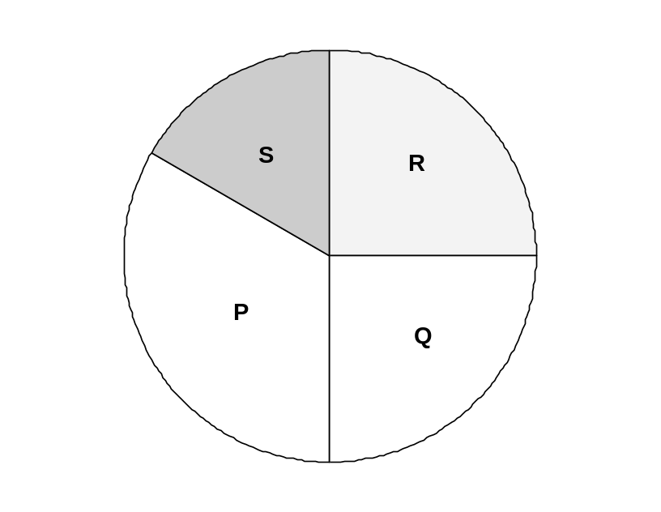
5 Which shop sold the least of computers?

- shop P
- shop Q
- shop R
- shop S

6 Which shop sold the same number of computers?

- shop R and shop Q
- shop Q and shop P
- shop R and shop P
- shop S and shop R

7 The table shows the time taken by four runners to complete a 200 m race.

Name | Time (second)
Bob | 45
Jeff | 30
Zul | 25
Tan | 35

Which bar graph is constructed correctly based on the given data?

A
Time (seconds)
0
5
10
15
20
25
30
35
40
45
Bob
Jeff
Zul
Tan
Name

B
Time (seconds)
0
5
10
15
20
25
30
35
40
45
Bob
Jeff
Zul
Tan
Name

C
Time (seconds)
0
5
10
15
20
25
30
35
40
45
Bob
Jeff
Zul
Tan

Name

D
Time (seconds)

0
5
10
15
20
25
30
35
40
45
Bob
Jeff
Zul
Tan
Name

8 The table shows the number of goals scored by three players in a football match.

Name of players | Number of goals scored
Azman | 3
Chieputa | 5
Marlon | 2

Which of the pie charts represents the data in the table?

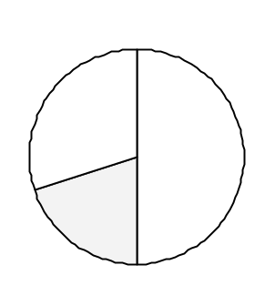

A

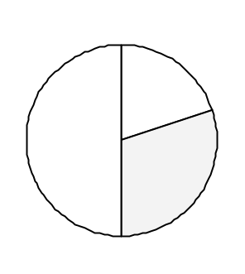

B

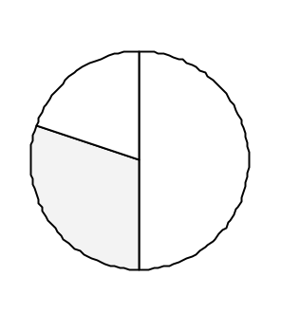
Chieputa
C
Azman

Marlon



P Q R

9. Which is the suitable formula to find the average of the leaf in each box?

- P + Q – R
    - 3

- P + Q + R
    - 3

- P – Q + R
    - 3

Question 10 – 12 are based on the pie chart below.

There are 2 000 books in Desa Wawasan Library.
The pie chart shows the percentage of books in Desa Wawasan Library.
Reference
20%
Others
10%
Fiction
30%
Novel
40%

10 What is the fraction of the novel?

D

11 How many percent of the books are fiction?

- 20%
- 25%
- 30%
- 35%

12 State the difference between the most and the least number of books.

- 30
- 200
- 600
- 800

13 The table shows the number of books read by four pupils.

Name | Books
Mei Ling | 4
Vijay | 2
Amirah | 8
Sufian | 6

Which of the pictographs represents the given data?

A

Mei Ling | 
Vijay
Amirah
Sufian

represents 2 books

B

Mei Ling
Vijay
Amirah
Sufian

represents 2 books

C
Mei Ling
Vijay
Amirah
Sufian

represents 2 books

D

Mei Ling
Vijay
Amirah
Sufian

represents 2 books

Question 14 – 15 are based on the bar graph below.

The bar graph shows the races of pupils in a school in Sarawak.

Number of Pupils
0
100
200
300
400
Malay
Chinese
Iban
Melanau
Races

14 What is the total number of pupils in the school?

- 900
- 850
- 750
- 350

15 What is the difference in number between Malay and Iban?

- 500
- 350
- 250
- 100

16 The pie chart shows the sales of reference books, according to subjects, in a bookshop. The total number of books sold is 1 750. 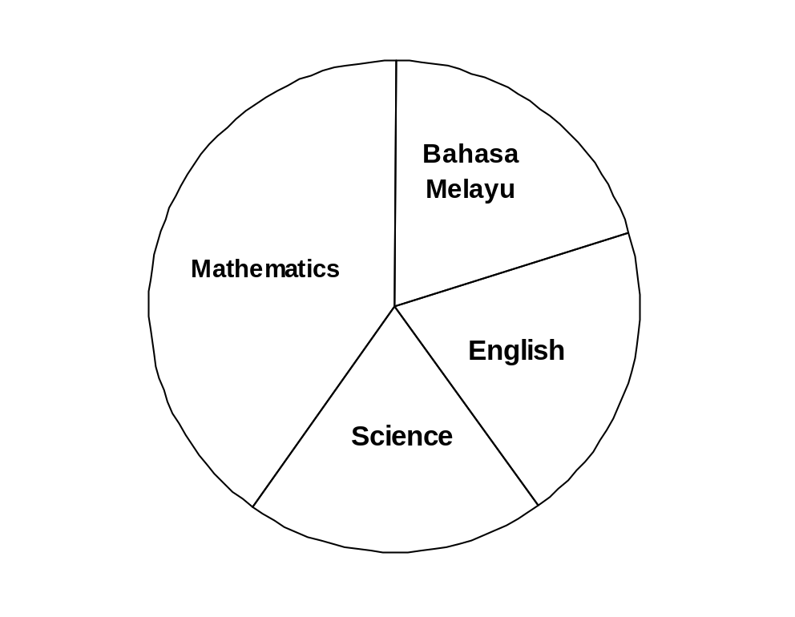

Find the number of Mathematics books sold.

- 350
- 700
- 1 050
- 1 400

17 A box contains 250 pens. of the pens are black,  of the pens are blue and the remainder are red pens. Which of the pictographs describes the given information?

A

Black | 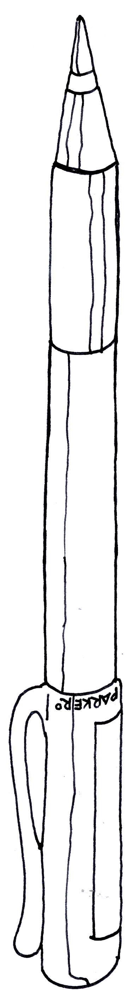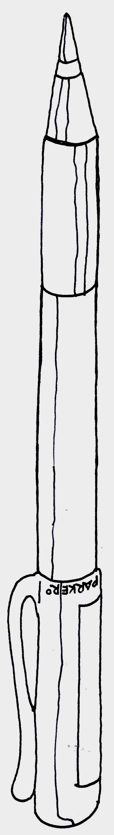
Blue
Red

represent 25 pens
B
Black
Blue
Red

represent 25 pens

C
Black
Blue
Red
represent 25 pens

D
Black
Blue
Red
represent 25 pens

Question 18 – 20 are based on the bar graph below.

The bar graph shows the number of pupils who passed in the Mathematics test in
the different classes.

Number of Passes

6R
6S
6T
6U
Class

18 15 pupils in the Class 6R passed the Mathematics test.
Find the number of passes in the Class 6S.

- 4

- 10

- 20

- 25

19 What is the difference in number of passes between Class 6T and Class 6U?

- 20

- 15

- 10

- 3

20 How many pupils seated for the test, if 10 pupils failed?

- 90

- 80

- 70

- 60


16
17
18
19
20
A
B
C
D
E
A
B
C
D
E
A
B
C
D
E
A
B
C
D
E
A
B
C
D
E
21
22
23
24
25
A
B
C
D
E
A
B
C
D
E
A
B
C
D
E
A
B
C
D
E
A
B
C
D
E
26
27
28
29
30
A
B
C
D
E
A
B
C
D
E
A
B
C
D
E
A
B
C
D
E
A
B
C
D
E
Tahun/ Tingkatan : 6
Mata Pelajaran: MATEMATIK
GUNAKAN PENSIL 2B ATAU BB SAHAJA.
TENTUKAN TIAP-TIAP TANDA ITU HITAM DAN MEMENUHI KESELURUHAN RUANG.
PADAMKAN HINGGA HABIS MANA-MANA TANDA YANG ANDA UBAH
SILA HITAMKAN JAWAPAN DI BAWAH MENGIKUT HURUF JAWAPAN YANG ANDA PILIH

KEMENTERIAN PELAJARAN MALAYSIA
KERTAS JAWAPAN OBJEKTIF
Ujian Diagnostik
511
52
53
54
55
A
B
C
D
E
A
B
C
D
E
A
B
C
D
E
A
B
C
D
E
A
B
C
D
E
56
57
58
59
60
A
B
C
D
E
A
B
C
D
E
A
B
C
D
E
A
B
C
D
E
A
B
C
D
E
46
47
48
49
50
A
B
C
D
E
A
B
C
D
E
A
B
C
D
E
A
B
C
D
E
A
B
C
D
E
411
42
43
44
45
A
B
C
D
E
A
B
C
D
E
A
B
C
D
E
A
B
C
D
E
A
B
C
D
E
31
32
33
34
35
A
B
C
D
E
A
B
C
D
E
A
B
C
D
E
A
B
C
D
E
A
B
C
D
E
36
37
38
39
40
A
B
C
D
E
A
B
C
D
E
A
B
C
D
E
A
B
C
D
E
A
B
C
D
E
1
2
3
4
5
A
B
C
D
E
A
B
C
D
E
A
B
C
D
E
A
B
C
D
E
A
B
C
D
E
6
7
8
9
10
A
B
C
D
E
A
B
C
D
E
A
B
C
D
E
A
B
C
D
E
A
B
C
D
E
11
12
13
14
15
A
B
C
D
E
A
B
C
D
E
A
B
C
D
E
A
B
C
D
E
A
B
C
D
E
Konstruk
No. Soalan
Jumlah Soalan
Bilangan Soalan
Gagal Dijawab
Kegunaan Guru
K5
K6
K7
K10
1-4
5-6
7-9
10-20
4
2
3
11
1
9
2
3
10
4
5
6
7
8
Nama Pelajar:
Nama Sekolah:
Modul: 11

