MODULE 1: WHOLE NUMBERS

Arahan:

- Modul ini mengandungi tiga puluh tujuh soalan. Semua soalan adalah dalam bahasa Inggeris.
- Modul merangkumi enam konstruk yang diuji
K1 - Memahami soalan dalam bahasa Inggeris
K3 - Memahami istilah matematik dalam bahasa Inggeris
K5 - Menguasai konstruk pengetahuan
K6 - Menguasai konstruk kefahaman
K7 – Menguasai konstruk kemahiran
K10 – Memahami pengajaran dan pembelajaran dalam bahasa Inggeris

- Murid hendaklah menulis maklumat diri dalam kertas jawapan objektif disediakan. Murid juga perlu memastikan maklumat konstruk, nombor soalan dan jumlah soalan seperti yang dibaca oleh guru di dalam ruangan disediakan dalam kertas jawapan objektif sebelum ujian.

- Bagi soalan objektif, anda perlu menandakan jawapan dengan menghitamkan pilihan jawapan pada pilihan jawapan A , B , C atau D pada kertas jawapan objektif.

Contoh:

Antara berikut, yang manakah haiwan?

A. Pokok B. Kambing C. Kereta D. Pen
D
A
B
C
E

- Untuk soalan subjektif, jawapan hendaklah ditulis pada kertas berasingan yang disediakan oleh guru.

- Jawab semua soalan.

Modul ini mengandungi 14 halaman bercetak

- Three hundred thirty thousand seven hundred and five written in numerals is

  - 33 075
  - 330 705
  - 3 003 075
  - 3 307 005

- Six and a quarter million is

- 6million
- 6 million
- 6million
- 6 million

- Which of the following express multiplication is a process of repeated addition?

  - 8 ÷ 8 ÷ 8
  - 8 – 8 – 8
C 8 × 8 × 8
  - 8 + 8 + 8

- 1000 beads were distributed equally among Ani , Zainab, Sharmiza and
How many beads did each of them get?

- 4 000
B 1 000
C 250
- 200

- The diagram shows three number cards.
4
8
2

Which of the following is the possible number that can be form, from the number cards?

    - 156
    - 842
    - 906
    - 376

- 1 million =

      - 1 000 000
      - 100 000
      - 10 000
      - 1 000

- What is the value of digit 8 in 3 854 167

    - 80 000
    - 800 000
    - 8 000 000

- The place value of digit 7 in the number 1 907 463 is

    - Hundreds
    - Thousands
    - Ten thousands

- Which of the following numbers are arranged in descending order?

    - 9 733 , 9 377 , 9 737 , 9 337
    - 9 737 , 9 733 , 9 377 , 9 337
    - 9 337 , 9 377 , 9 733 , 9 737
    - 9 377 , 9 733 , 9 337 , 9 737

- Which step shows the difference between 1 000 and 132 001 ?

    - 132 001 – 1 000
    - 132 001 + 1 000
    - 132 001 × 1 000
    - 132 001 1 000

- 742 804 = 40 000 + M + 2 000 + 700 000 + 4

What is the value of M?

    - 80 000
    - 8 000
    - 800
    - 80

- Find the number that has 5 in the tens place.

    - 6 481 057
    - 7 862 526
    - 3 426 435
    - 8 254 279

- Which of the following numbers represented by the spike abacus?

M H Th T Th Th H T O

    - 2 508 934
    - 4 398 052
    - 439 852

- Round off to the place value of the underlined digit.

6 537 281

    - 6 538 000
    - 6 540 000
    - 6 530 000
    - 6 534 000

- When 2 604 300 is partitioned according to the value of digit, it becomes

    - 2 millions + 6 hundred thousands + 4 thousands + 3 hundreds
    - 2 millions + 6 ten thousands + 4 thousands + 3 hundreds
    - 2 millions + 6 hundred thousands + 4 ten thousands + 3 hundreds
    - 2 millions + 6 ten thousands + 4 thousands + 3 hundreds

- The diagram shows a number pattern.
3 107 525 , 3 106 525 ,3 105 525 , _______ , 3 103 525

What is the missing number?

- 3 104 525
- 3 105 425
- 3 105 625

7 300 000

The above number has been rounded off to the

- nearest thousand
- nearest ten thousand
- nearest hundred thousand
- nearest million

- X = 5 hundred thousands + 6 thousands + 3 hundred + 4 ones

What is the value of X ?

        - 500 634
        - 506 304
        - 506 340
        - 506 034

- Multiply 4 325 by 1 000

        - 4 325 000
        - 432 500
        - 43 250
        - 4 325

- Round off 699 593 to the nearest ten thousand.

        - 700 000
        - 690 000
        - 6 100 000

- – 557 000 = 43 549

What is the possible number in the box?

        - 600 549
        - 514 549
        - 513 451
        - 514 459

- The diagram shows a number line.

364 500 364 750 365 000 X 365 500

What is the value of X ?

        - 365 050
        - 365 450
        - 365 250
        - 365 750

- The diagram shows a number card.

945 327

Which of the following statements is true?

  - The place value of 5 is hundred.
  - It becomes 900 000 when rounded off to the nearest thousand.
  - It lies between 900 000 and 1 000 000.

- There are 5 similar basket contain between 80 to 100 oranges.
What is the most accurate estimate the total number of oranges?

- 185
- 390
- 450
- 510

- The diagram shows the number of buns in a packet.

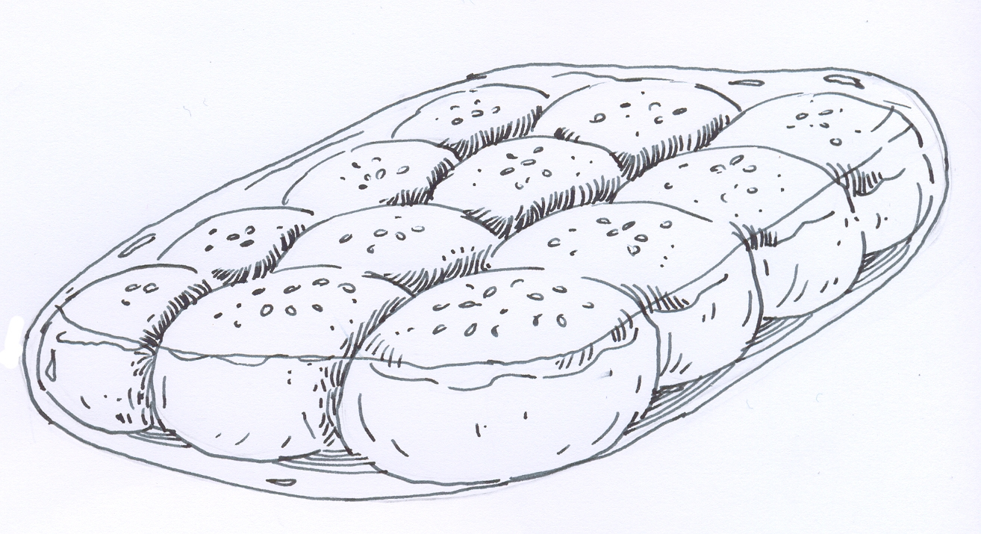

Syarikat Asha supplied a few packet of buns to SK Tanjung Malim. 604 pupils were given 3 buns each. How many packets of buns did Syarikat Asha supply?

- 2416
- 1812
- 619
- 151

- Find the difference between 527 205 and 8 hundred thousand.

- 727 205
- 526 405
- 327 205
- 272 795

- Which of the following has the largest value?

- 4.08 million
- 4 800 000
- 4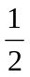 million
- 4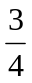million

- The diagram shows two number cards.

513 247
982 760

Find the product of the value of digit 3 and the value of digit 6.

- A Two thousand nine hundred and forty
- B One hundred and eighty thousand
- C Three thousand and sixty
- Eighteen thousand

- million + 0.75 million =

- 1 250 000
- 800 000
- 575 000
- 125 000
- How much must be added to 523 417 to make 800 000?

  - 276 583
  - 323 417
  - 1 323 417

- Take away 560 036 and 209 987 from 8 431 256 .

  - 350 049
  - 770 023
  - 7 661 233
  - 7 871 220

- Soalan ini akan dibaca oleh guru.

  - 63
  - 70
  - 144
  - 441

- A

  - 480 000
  - 490 000
  - 400 000
  - 500 000

  - 3425
  - 690
  - 680
  - 137

  - 4 751
  - 4 621
  - 3 429
  - 1 065

A | 9 350
B | 93 500
C | 747 992
D | 5 984 000

State | Population
Perlis  Kedah  Pulau Pinang  Perak | 228 000  1 882 000  1 492 400  2 283 000

A | Perlis
B | Kedah
C | Pulau Pinang
D | Perak



16
17
18
19
20
A
B
C
D
E
A
B
C
D
E
A
B
C
D
E
A
B
C
D
E
A
B
C
D
E
21
22
23
24
25
A
B
C
D
E
A
B
C
D
E
A
B
C
D
E
A
B
C
D
E
A
B
C
D
E
26
27
28
29
30
A
B
C
D
E
A
B
C
D
E
A
B
C
D
E
A
B
C
D
E
A
B
C
D
E
Tahun/ Tingkatan : 6
Mata Pelajaran: MATEMATIK
GUNAKAN PENSIL 2B ATAU BB SAHAJA.
TENTUKAN TIAP-TIAP TANDA ITU HITAM DAN MEMENUHI KESELURUHAN RUANG.
PADAMKAN HINGGA HABIS MANA-MANA TANDA YANG ANDA UBAH
SILA HITAMKAN JAWAPAN DI BAWAH MENGIKUT HURUF JAWAPAN YANG ANDA PILIH

KEMENTERIAN PELAJARAN MALAYSIA
KERTAS JAWAPAN OBJEKTIF
Ujian Diagnostik
511
52
53
54
55
A
B
C
D
E
A
B
C
D
E
A
B
C
D
E
A
B
C
D
E
A
B
C
D
E
56
57
58
59
60
A
B
C
D
E
A
B
C
D
E
A
B
C
D
E
A
B
C
D
E
A
B
C
D
E
46
47
48
49
50
A
B
C
D
E
A
B
C
D
E
A
B
C
D
E
A
B
C
D
E
A
B
C
D
E
411
42
43
44
45
A
B
C
D
E
A
B
C
D
E
A
B
C
D
E
A
B
C
D
E
A
B
C
D
E
31
32
33
34
35
A
B
C
D
E
A
B
C
D
E
A
B
C
D
E
A
B
C
D
E
A
B
C
D
E
36
37
38
39
40
A
B
C
D
E
A
B
C
D
E
A
B
C
D
E
A
B
C
D
E
A
B
C
D
E
1
2
3
4
5
A
B
C
D
E
A
B
C
D
E
A
B
C
D
E
A
B
C
D
E
A
B
C
D
E
6
7
8
9
10
A
B
C
D
E
A
B
C
D
E
A
B
C
D
E
A
B
C
D
E
A
B
C
D
E
11
12
13
14
15
A
B
C
D
E
A
B
C
D
E
A
B
C
D
E
A
B
C
D
E
A
B
C
D
E
Konstruk
No. Soalan
Jumlah Soalan
Bilangan Soalan
Gagal Dijawab
Kegunaan Guru
K1
K3
K5
K6
K7
K10
1-3
4-5
6-9
10-24
24-31
32-37
5
5
6
7
8
9
1
9
2
3
10
4
5
6
7
8
Nama Pelajar:
Nama Sekolah:
Modul: 1

